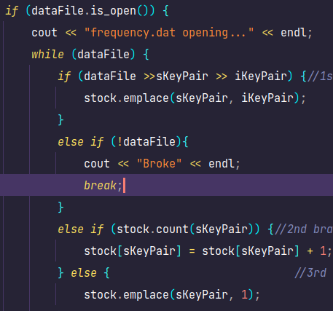
Inventory:
I had trouble populating the map properly. Initially, it wouldn’t even open the file properly. There are many artifacts of this as a result strewn across the program. To demystify this tree, the first branch is triggered only IF the frequency.dat has already been saved over once. The later two spokes are triggered if frequency.dat is in the format of strings delimited by newlines, by which case it will count them and then populate the map.
UI:
This file was born out of a want to have backend functions separated from frontend functions. In it, all menus and how theyre actually connected are described.

